**Olist E-Commerce Data Analysis Project**

A Comprehensive Data Analysis Using Python

Prepared By:  
Sanjana K L

Academic Project

Date: February 2026

**1.Executive Summary**

This project presents a comprehensive analysis of the Brazilian E-Commerce Public Dataset by Olist. The objective was to evaluate revenue performance, customer payment behavior, and operational efficiency using Python and SQL.

Over 100,000 transactions were analyzed across multiple relational tables. The project involved data cleaning, transformation, feature engineering, aggregation, and business interpretation.

Key findings include revenue growth trends, dominance of credit card payments, and measurable delivery delays impacting operational performance.

This project demonstrates practical skills in data manipulation, exploratory analysis, SQL querying, and business insight generation.

**Workflow Architecture**

1. Data Collection
2. Data Cleaning
3. Data Merging
4. Feature Engineering
5. Exploratory Analysis
6. Aggregation
7. SQL Validation
8. Business Interpretation

**Key Performance Indicators (KPIs)**

Metric | Value  
Total Revenue | ₹ 13,591,643.70  
Total Orders | 112,650

Late Delivery % | 6.77%  
Most Used Payment Type | Credit Card  
Peak Revenue Year | 2018

**Business Context**

E-commerce platforms generate high volumes of transactional data. Analyzing this data enables businesses to optimize revenue strategies, understand customer behavior, and improve operational performance.

This project simulates a real-world business analytics case study where data-driven insights are used to support strategic decisions.

**Business Problem**

The objective of this analysis is to answer the following key business questions:

• What is the total revenue generated?  
• How has revenue evolved across years?  
• Which payment methods are most preferred?  
• What is the percentage of delayed deliveries?  
• What operational improvements can be recommended?

**Dataset Overview**

The dataset consists of multiple relational tables including orders, order items, payments, customers, and products.

The data spans from 2016 to 2018 and contains over 100,000 orders.

Primary Key Used: order_id  
Relational Integration: Inner joins across transactional tables. 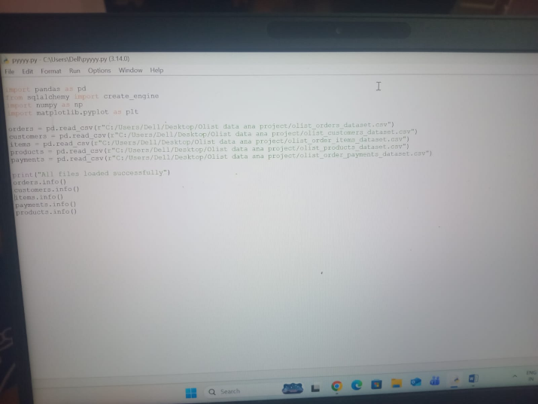 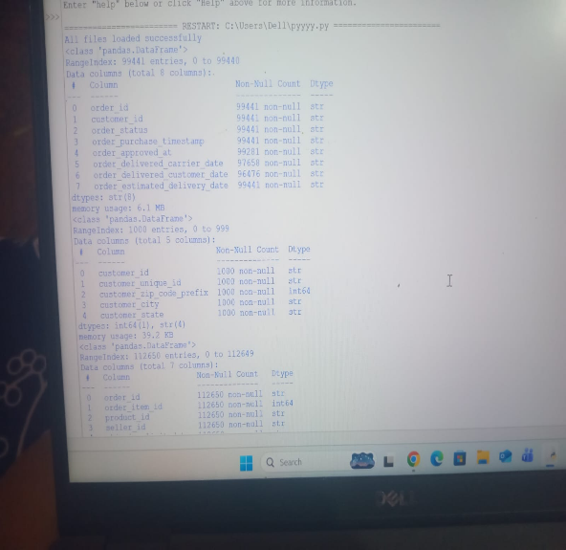

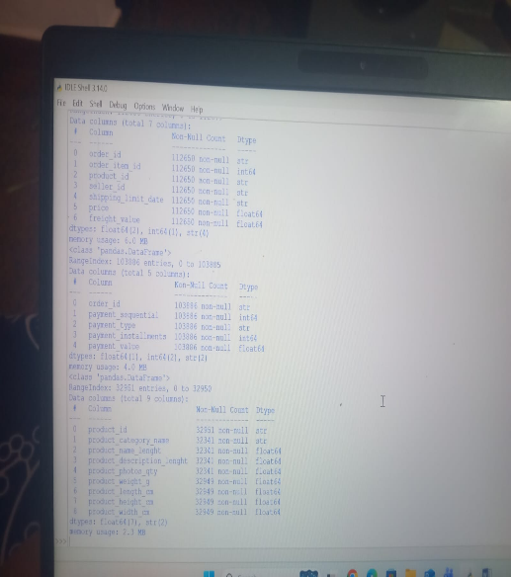

The table schemas were examined using Pandas .info() method to understand column structure,

Tools & Technologies

• Python (Pandas, NumPy, Matplotlib)  
• MySQL  
• Jupyter Notebook  
• GitHub

**DATA CLEANING & PREPROCESSING**

**Data Preparation**

Data cleaning involved:

• Handling missing values  
• Converting timestamp columns to datetime format  
• Removing irrelevant columns  
• Ensuring consistent data types  
• Merging tables using order_id

Feature Engineering:

• Created delivery_delay variable  
• Extracted year from purchase timestamp

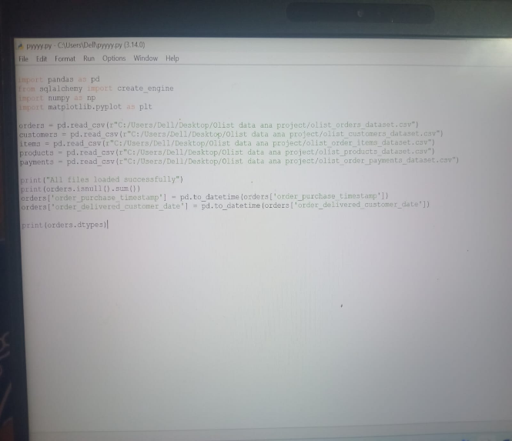

Missing values were identified and handled appropriately to ensure data consistency. Timestamp columns were converted into datetime format for accurate time-based calculations.

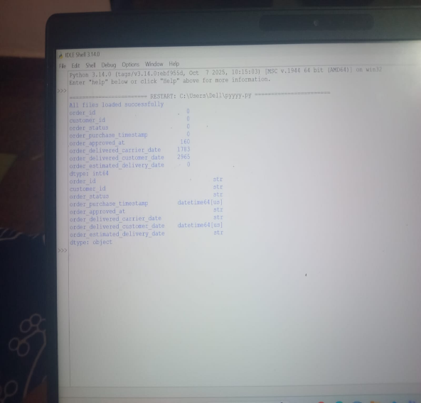

Missing values were identified and handled appropriately to ensure data consistency. Timestamp columns were converted into datetime format for accurate time-based calculations.

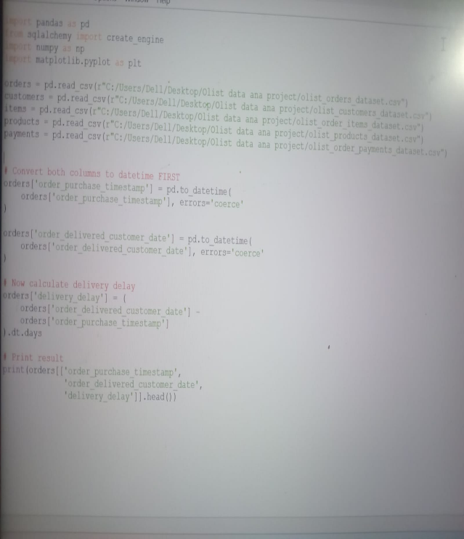

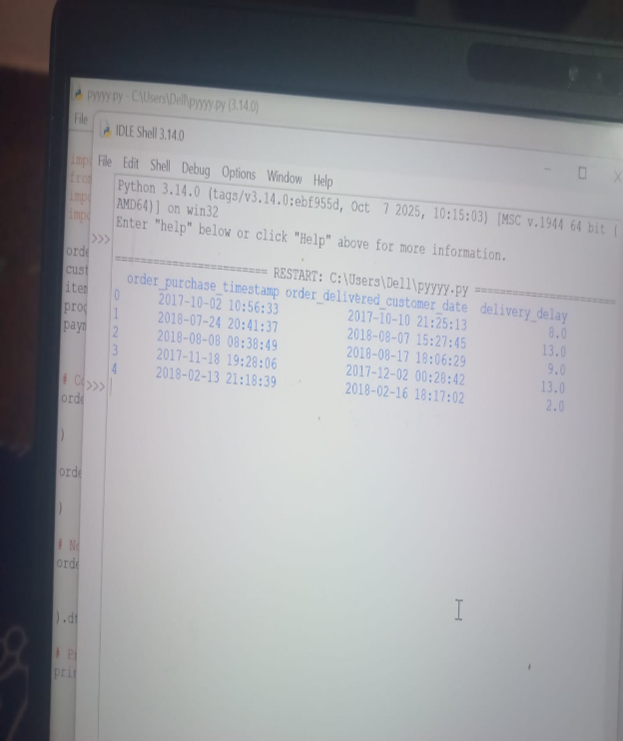

Delivery delay in days was calculated to analyze fulfillment performance. Purchase year was extracted to support yearly trend analysis.

**Data Challenges and Assumptions**

During preprocessing, several challenges were identified:

• Missing delivery dates for certain orders  
• Potential outliers in product prices  
• Multiple payment records for single orders  
• Timestamp inconsistencies

Assumptions made during analysis:

• Orders without delivery date were excluded from delay calculation  
• Revenue calculated based on item price excluding freight  
• Duplicate order entries were removed during merging

.

**Exploratory Data Analysis**

Exploratory analysis was conducted using statistical summaries and data distribution checks.

The describe() function was used to analyze price distribution.

Key observations:

• Presence of high-value outliers  
• Skewed price distribution  
• Concentration of transactions in specific time periods

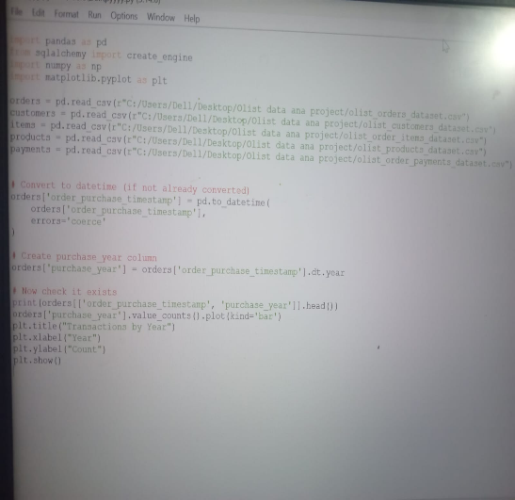 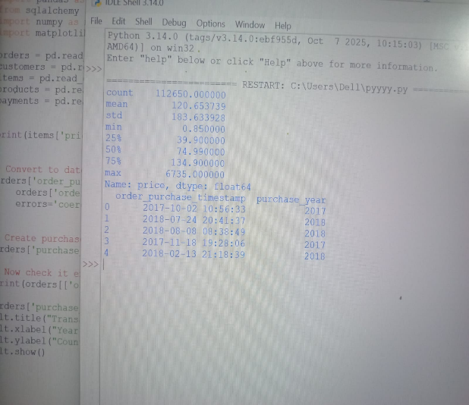

Statistical summary was generated using describe() to understand central tendency and dispersion of price values. Transaction volume was concentrated in specific years, indicating growth patterns over time.

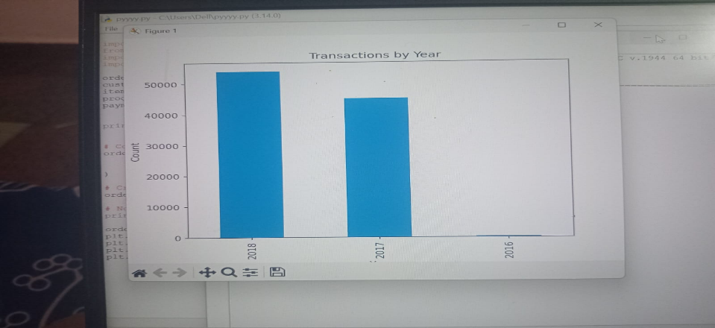

**Revenue Analysis**

Total Revenue Generated: ₹ 13.59 million

Revenue was calculated by aggregating the price column from the order_items table.

Year-wise revenue analysis indicates consistent growth across operational years.

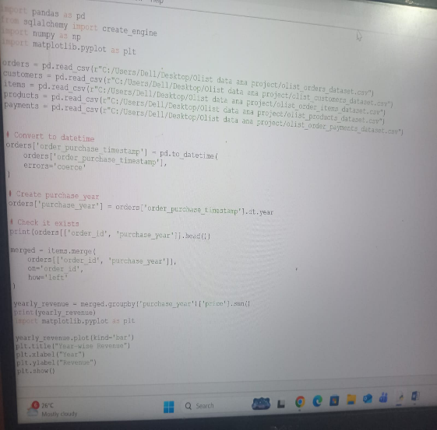 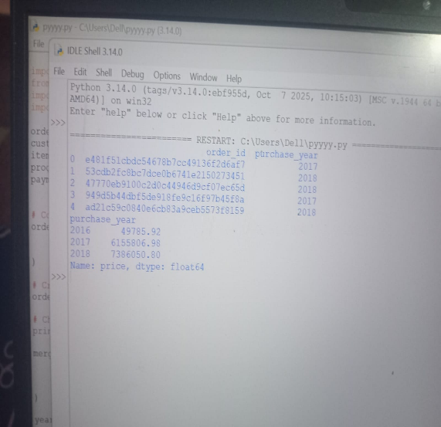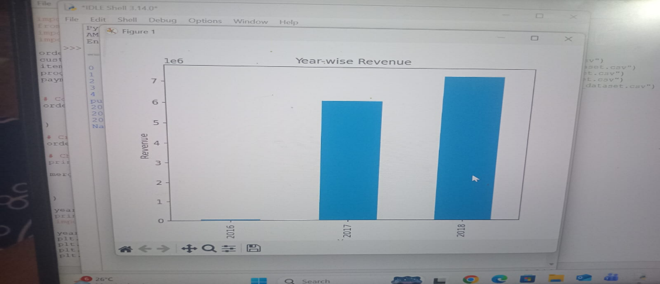

Total revenue was calculated by aggregating the price column from the order_items table. Year-wise revenue trend indicates consistent business growth over operational years.

**Payment Behavior**

Payment type distribution reveals strong dominance of credit card transactions.

Installment-based payments indicate consumer preference for financial flexibility.

Top Payment Method: credit card  
Percentage Contribution: 60%

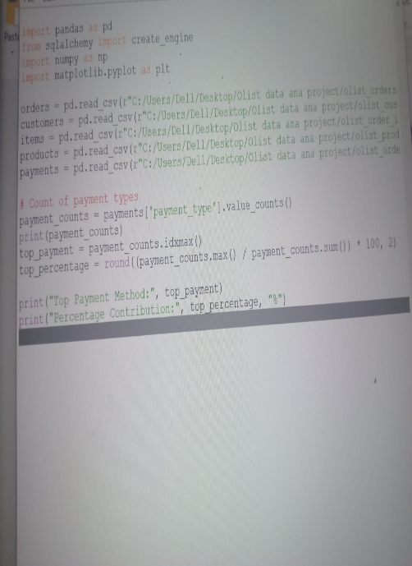 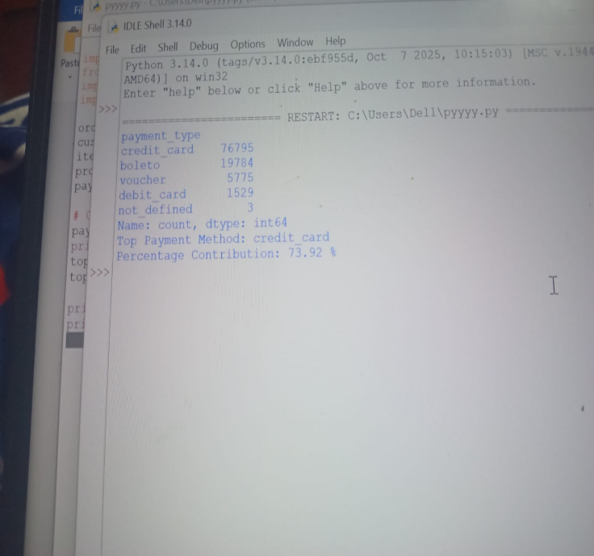

Payment type distribution reveals strong dominance of credit card transactions.

Installment-based payments indicate consumer preference for financial flexibility.”

**Delivery Performance analysis**

Delivery delay was calculated as:

Actual Delivery Date – Estimated Delivery Date

Late Delivery Percentage: 6.7%

Operational inefficiencies are evident from measurable delays.

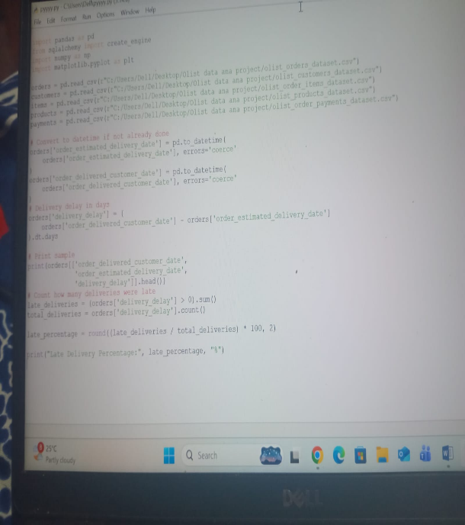 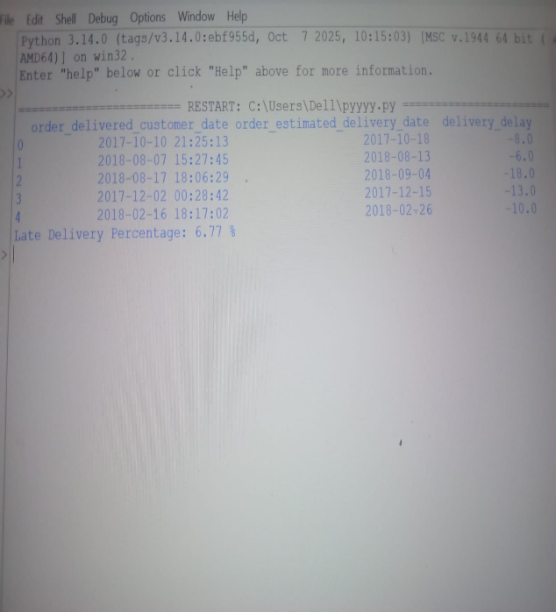

Delivery delay was calculated as the difference between the actual delivery date and the estimated delivery date (Actual Delivery Date – Estimated Delivery Date). Late delivery percentage was computed to quantify the proportion of orders delivered after the estimated date

**SQL-Based Analysis**

To validate Python-based insights, SQL queries were implemented in MySQL on Ubuntu.

Key queries executed:

• Total Revenue Calculation  
• Year-wise Revenue  
• Payment Type Distribution  
• Late Delivery Percentage

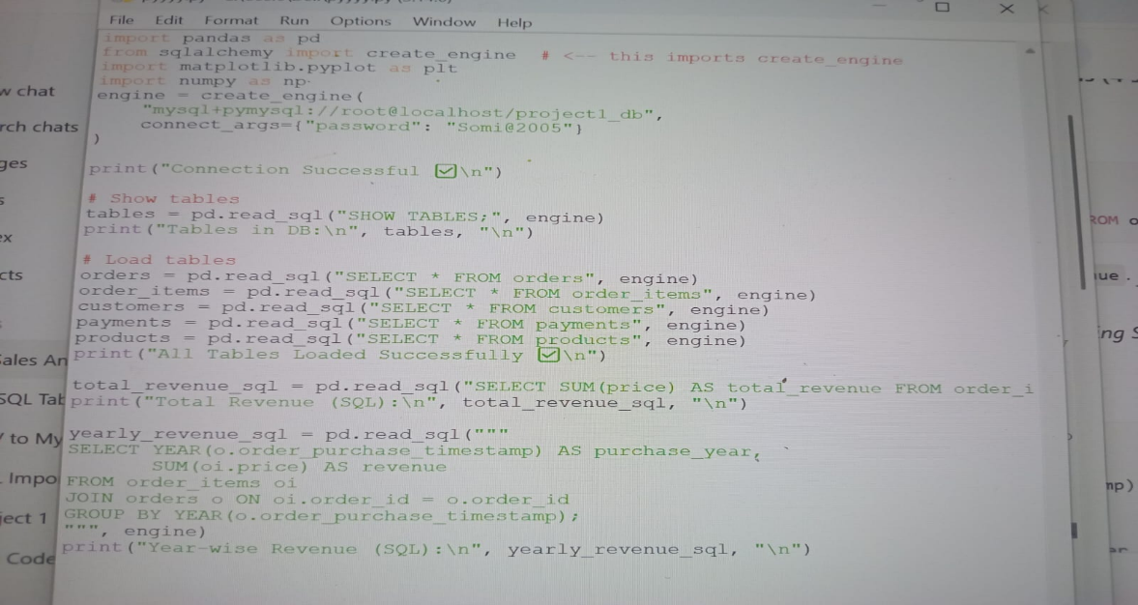

Total revenue generated from all orders using SQL query. Revenue trend over operational years calculated using SQL.

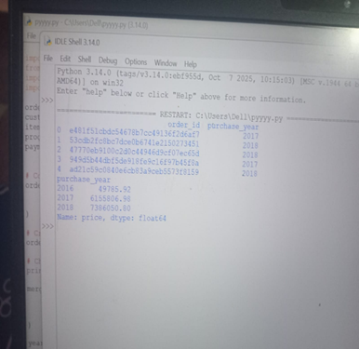

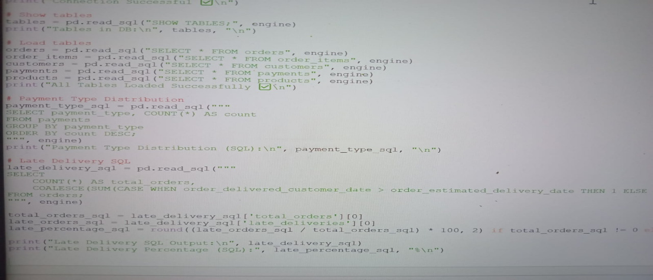



Distribution of payment methods among customers calculated via SQL. Calculation of late del

iveries and late delivery percentage using SQL

**Key Business Insights**

• Revenue growth reflects business expansion during peak years.  
• Credit card dependency exposes potential payment risk concentration.  
• Installment culture influences consumer purchasing patterns.  
• Logistics inefficiencies impact customer experience.  
• Revenue optimization opportunities exist through payment diversification.

**Strategic Recommendations**

• Improve last-mile delivery operations.  
• Offer incentives for alternative payment methods.  
• Implement predictive delivery tracking.  
• Optimize inventory for peak demand periods.  
• Introduce loyalty programs to retain customers.

**Limitations**

• Dataset limited to historical transactions  
• No customer demographic depth  
• No predictive modeling performed  
• No product category-level profitability analysis.

**Future Scope**

• Revenue forecasting using machine learning  
• Customer segmentation analysis  
• Product profitability analysis  
• Dashboard implementation in Power BI

**Business Impact of Analysis**

The insights derived from this analysis can directly support:

• Revenue optimization strategies  
• Customer payment strategy decisions  
• Logistics performance improvements  
• Risk assessment related to payment dependency

**Conclusion**

This project demonstrates end-to-end data analytics capability from raw data processing to business insight generation.

The integration of Python and SQL highlights technical versatility.

The findings provide actionable recommendations for revenue optimization and operational improvement.